#include<stdio.h>

main()

{

printf("Shadman Ahnaf ID: 23103065\n");

int day;

printf("Enter the number of a day:");

scanf("%d",&day);

switch(day)

{

case 1:

printf("Saturday");

break;

case 2:

printf("Sunday");

break;

case 3:

printf("Monday");

break;

case 4:

printf("Tuesday");

break;

case 5:

printf("wednesday");

break;

case 6:

printf("Thusday");

break;

case 7:

printf("Friday");

break;

default:

printf("Invalid Number");

}

}

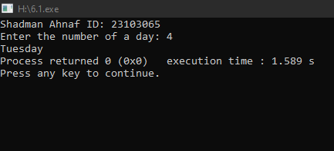

#include<stdio.h>

main()

{

printf("Shadman Ahnaf ID: 23103065\n");

int month;

printf("Enter the number of month:");

scanf("%d",&month);

switch(month)

{

case 1:

case 3:

case 5:

case 7:

case 8:

case 10:

case 12:

printf("This Month has 31 days");

break;

case 4:

case 6:

case 9:

case 11:

printf("This month has 30 days");

break;

case 2:

printf("This month has 28/29 days");

break;

default:

printf("Invalid number");

}

}

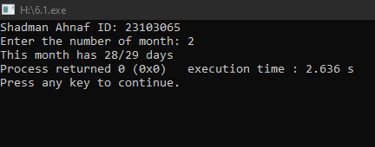

#include<stdio.h>

main()

{

printf("Shadman Ahnaf ID: 23103065\n");

char alphabet;

printf("Enter an Alphabet:");

scanf("%c",&alphabet);

switch(alphabet)

{

case 'a':

case 'A':

case 'e':

case 'E':

case 'i':

case 'I':

case 'o':

case 'O':

case 'u':

case 'U':

printf("%c is Vowel",alphabet);

break;

default:

printf("%c is consonant",alphabet);}}

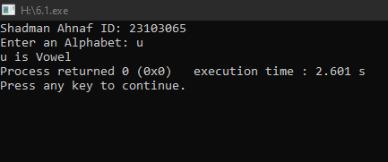

#include<stdio.h>

main()

{

printf("Shadman Ahnaf ID: 23103065\n");

int a,b;

printf("Enter two numbers:\n");

scanf("%d%d",&a,&b);

switch(a>b)

{

case 0:

printf("%d is the maximum",b);

break;

case 1:

printf("%d is the maximum",a);

break;}

}

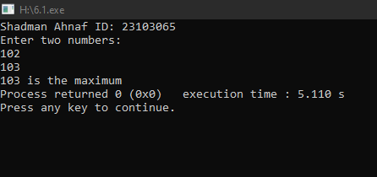

#include<stdio.h>

main()

{

printf("Shadman Ahnaf ID: 23103065\n");

int a;

printf("Enter a number:");

scanf("%d",&a);

switch(a%2==0)

{

case 0:

printf("Odd");

break;

case 1:

printf("Even");

break;

}

}

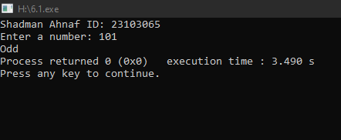

#include<stdio.h>

main()

{

printf("Shadman Ahnaf ID: 23103065\n");

int num;

printf("Enter a number: ");

scanf("%d",&num);

switch(num>0)

{

case 1:

printf("%d is positive",num);

break;

case 0:

switch(num<0)

{

case 1:

printf("%d is negative",num);

break;

case 0:

switch(num==0)

{

case 1:

printf("%d is zero",num);

break;

}

}

}

}

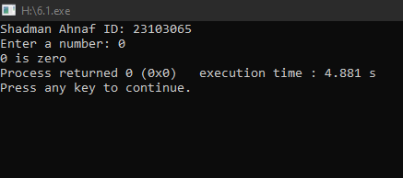

#include<stdio.h>

main()

{

printf("Shadman Ahnaf ID: 23103065\n");

float a,b,result;

char opt;

printf("Enter first number:");

scanf("%f",&a);

printf("Enter an operator(+,-,\*,/):");

scanf("\n%c",&opt);

printf("Enter second number:");

scanf("%f",&b);

switch(opt)

{

case'+':

result = a+b;

printf("Result:%.2f\n",result);

break;

case'-':

result = a-b;

printf("Result:%.2f\n",result);

break;

case'\*':

result = a\*b;

printf("Result:%.2f\n",result);

break;

case'/':

result = a/b;

printf("Result:%.2f\n",result);

break;

}

}

